# 13 Leadership Effectiveness

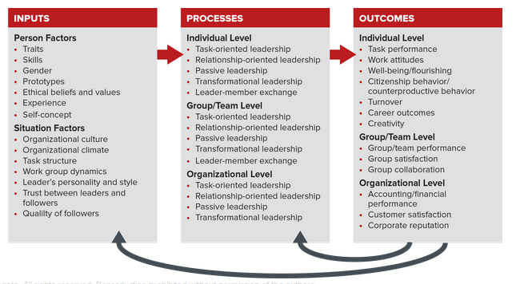

## 13.1 Making Sense of Leadership Theories,

Leadership is a process whereby an individual influence a group of individuals to achieve a common goal. As Adams suggested, you do not need to have a formal position of authority to be a leader. Anyone who exerts influence over others in the pursuit of organizationally relevant matters is a leader.

An Integrated Model of Leadership,

Figure 13.2 presents an integrated model of leadership. Starting at the far right of the model, you see that leadership effectiveness is the outcome we explain in this chapter. The center of the model shows this outcome is influenced by four types of leadership behavior: task-oriented, relationship-oriented, passive, and transformational. Effective leadership also is affected by a combination of task-oriented traits and interpersonal attributes (the left side of the model). Recall from Chapter 3 that individual differences significantly affect performance, and they vary from relatively fixed (cognitive ability) to somewhat flexible (self-efficacy). For example, a recent study of 17,000 people found that childhood intelligence predicted leadership potential across four decades.

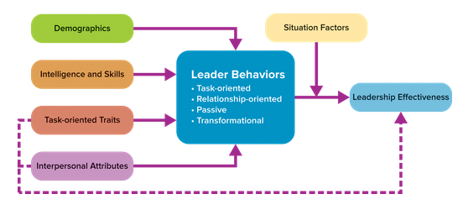

What Is the Difference between Leading and Managing?

Bernard Bass, a leadership expert, concluded, Leaders manage and managers lead, but the two activities are not synonymous. Broadly speaking, managers typically perform functions associated with planning, investigating, organizing, and control, and leaders focus on influencing others. Leaders inspire others, provide emotional support, and try to get employees to rally around a common goal. Leaders also play a key role in creating a vision and strategic plan for an organization. Managers, in turn, are charged with implementing the vision and plan. We can draw several conclusions from this division of labor.

First, good leaders are not necessarily good managers, and good managers are not necessarily good leaders. Second, effective leadership requires effective managerial skills at some level. For example, United’s former CEO Jeff Smisek resigned due to managerial deficiencies that produced labor problems, poor customer service, and poor financial results. In contrast, both Tim Cook, CEO of Apple, and Mary Dillon, CEO of Ulta Beauty, are recognized for their use of good managerial skills when implementing corporate strategies.

## 13.2 Trait Theories: Do Leaders Possess Unique Traits and Personal Characteristics?

Trait theory is the successor to what was once called the great man theory of leadership. This approach was based on the assumption that leaders such as Abraham Lincoln, Martin Luther King Jr., and Margaret Thatcher are born with some innate ability to lead. In contrast, trait theorists believe leadership traits are not inborn but can be developed through experience and learning. The trait approach attempts to identify personality characteristics or interpersonal attributes that differentiate leaders from followers.

What Core Traits Do Leaders Possess?

Researchers have attempted to identify leadership traits for nearly 100 years. It has been a frustrating pursuit that has not led to a consistent answer. Some have claimed that effective leaders are taller, bald, or wear glasses. But if instead you believe in drawing conclusions based on science, OB researchers offer you a statistical technique called meta-analysis. A meta-analysis is a statistical procedure that effectively computes an average relationship between two variables. Table 13.1 is a summary of what we know from this research. Note the emphasis on task-orientation and the expansion into interpersonal attributes.

All the traits and interpersonal attributes listed in Table 13.1 have been defined elsewhere in this book except for the dark triad traits of narcissism, Machiavellianism, and psychopathy.

Narcissism consists of a self-centered perspective, feelings of superiority, and a drive for personal power and glory. Individuals with this trait have inflated views of themselves, fantasize about being in control of everything, and like to attract the admiration of others. It’s thus not surprising that narcissists tend to emerge as leaders, even though they can promote counterproductive work behaviors from others.

Machiavellianism is the use of manipulation, a cynical view of human nature, and a moral code that puts results over principles. It’s not surprising that individuals who believe everyone lies to get what they want and that it’s necessary to cheat to get ahead are less likely to garner support from others.

Psychopathy is characterized by a lack of concern for others, impulsive behavior, and a lack of remorse or guilt when your actions harm others. This type of person is toxic at work.

What Role Does Emotional Intelligence Play in Leadership Effectiveness?

Recall from Chapter 3 that emotional intelligence is the ability to manage yourself and your relationships in mature and constructive ways. Scientific evidence supports two conclusions about emotional intelligence and leadership:

Emotional intelligence is an input to transformational leadership. In other words, emotional intelligence helps managers effectively enact the behaviors associated with transformational leadership, discussed later in this chapter.

Emotional intelligence has a small, positive, and significant association with leadership effectiveness. This suggests that emotional intelligence will help you lead more effectively, but it is not the secret elixir of leadership effectiveness.

Do Women and Men Display the Same Leadership Traits?

The increase in the number of women in the workforce has generated much interest in understanding the similarities and differences between female and male leaders. Research reveals the following four conclusions:

Men were observed to display more task leadership and women more relationship leadership.

Women used a more democratic or participative style than men, and men used a more autocratic and directive style.

Female leadership was associated with more cohesion, cooperative learning, and participative communication among team members.

Peers, managers, direct reports, and judges/trained observers, rated women executives as more effective than men. Men rated themselves as more effective than women evaluated themselves.

How Important Are Knowledge and Skills?

Knowledge and skills are extremely important! Table 13.2 identifies the four basic skills leaders need, according to researchers.

Do Perceptions Matter?

Perceptions do matter, according to implicit leadership theory. Implicit leadership theory proposes that people have beliefs about how leaders should behave and what they should do for their followers. These beliefs are summarized in a leadership prototype. A leadership prototype is a mental representation of the traits and behaviors people believe leaders possess. For example, a recent study identified a leadership prototype of physically imposing men: that they possess leadership ability and thus are granted greater status.

What Are the Take-Aways from Trait Theory?

Trait theory offers us four conclusions.

We cannot ignore the implications of leadership traits. Traits play a central role in the way we perceive leaders, and they do ultimately affect leadership effectiveness. For example, the Cardiac Rhythm Disease Management Group within Medtronic Inc. identified nine types of traits and skills necessary for leaders (such as giving clear performance feedback and being courageous). The company then designed a leadership development program to help its employees learn and apply these traits.

More companies are using management development programs to build a pipeline of leadership talent. Total US spending by organizations for leadership training was $61.8 billion in 2014 and $70.6 billion in 2015.

The positive and dark triad traits shown in Table 13.1 suggest the qualities you should cultivate and avoid if you want to assume a leadership role in the future. Personality tests, discussed in Chapter 3, and other trait assessments can help evaluate your strengths and weaknesses on these traits. The website for this book contains a host of tests you can take for this purpose.

Organizations may want to include personality and trait assessments in their selection and promotion processes. For example, Nina Brody, head of talent for Take Care Health Systems in Conshohocken, Pennsylvania, used an assessment tool to assist in hiring nurses, doctors, medical assistants, and others with traits that fit the organization’s culture. Of course, companies should match only valid leadership traits.

A global mind-set is an increasingly valued task-oriented trait. As more companies expand their international operations and hire more culturally diverse people for domestic operations in the United States, they want to enhance employees’ global mind-set. A global mind-set is the belief in one’s ability to influence dissimilar others in a global context. For example, MasterCard and InterContinental Hotels Group implemented leadership development programs aimed at enhancing employees’ cross-cultural awareness and ability to work with people from different countries (see the OB in Action box).

## 13.3 Behavioral Theories: Which Leader Behaviors Drive Effectiveness?

As you might expect, leaders rely on many different types of behaviors to influence others and to accomplish goals. This realization spurred the behavioral styles approach, which attempts to identify the unique behaviors displayed by effective leaders.

Task-Oriented Leader Behavior,

The primary purpose of task-oriented behaviors is to assist others in accomplishing their goals and those of the work unit. Although a host of behaviors fall under this category, such as planning, clarifying, monitoring, and problem solving, researchers have mainly studied two: initiating structure and transactional leadership.

Initiating Structure,

Researchers at Ohio State University defined initiating structure as leader behavior that organizes and defines what group members should be doing to maximize output. You witness this behavior style when someone organizes a team meeting for a class project or seeks input from a knowledgeable source to help guide the team’s work. This form of leadership has a moderately strong positive relationship with measures of leadership effectiveness.

Transactional Leadership,

Transactional leadership focuses on clarifying employees’ role and task requirements and providing followers with positive and negative rewards contingent on performance. Transactional leadership includes the fundamental managerial activities of setting goals, monitoring progress toward goal achievement, and rewarding and punishing people for their level of goal accomplishment. You can see that transactional leadership is based on using rewards and punishment to drive motivation and performance. Research supports a positive association between transactional leadership and leader effectiveness and group performance.

Relationship-Oriented Leader Behavior,

The purpose of relationship-oriented leadership is to enhance employees’ skills and create positive work relationships among coworkers and between the leader and his/her employees. OB researchers have investigated the impact of four relationship-oriented behaviors:

* Consideration
* Empowerment
* Servant-leadership
* Ethical leadership

Consideration,

Consideration is leader behavior that creates mutual respect or trust and prioritizes group members’ needs and desires. Consideration promotes social interactions and identification with the team and leader. In fact, researchers at Ohio State (who identified consideration) initially proposed that a high-initiating structure, high-consideration style would be the best style of leadership. While research results did not support this bold prediction, considerate leader behavior has a moderately strong positive relationship with measures of leadership effectiveness.

Empowering Leadership,

To explain the positive effects of empowering leadership, we need to define two terms. Empowering leadership represents the leader’s ability to create perceptions of psychological empowerment in others. Psychological empowerment, employees’ belief that they have control over their work, is believed to drive intrinsic motivation.

Servant-Leadership

The term servant-leadership was coined in 1970 by Robert Greenleaf, who believed great leaders act as servants and make the needs of others, including employees, customers, and community, their first priority. Servant-leadership focuses on increased service to others rather than to oneself. Because the focus of servant-leadership is on serving others, servant-leaders are less likely to engage in self-serving behaviors that hurt others. Embedding servant-leadership into an organization’s culture requires actions as well as words.

Servant-leadership is expected to promote leadership effectiveness because it focuses on providing support and growth opportunities to employees. As you may recall from our discussion of perceived organizational support (POS) in Chapter 2, people generally reciprocate with increased effort toward collective performance when they feel supported. Servant-leaders have the characteristics listed in Table 13.3.

Ethical Leadership

OB scholars are interested in studying ethical leadership. Ethical leadership represents normatively appropriate behavior that focuses on being a moral role model. This includes communicating ethical values to others, rewarding ethical behavior, and treating followers with care and concern.

Ethical leadership is clearly driven by personal factors related to our beliefs and values. It also has a reciprocal relationship with an organization’s culture and climate. In other words, an ethical culture and climate promote ethical leadership, and ethical leadership in turn promotes an ethical culture and climate. Although ethical leadership is a relatively new area of study in OB, research already shows that it is positively related to employee job satisfaction, organizational commitment, organizational citizenship behavior, motivation, and task performance. It also is negatively associated with job stress, counterproductive work behavior, and intentions to quit. It appears that ethical leadership has many positive benefits.

Passive Leadership

Passive leadership is best illustrated by what OB scholars call laissez-faire leadership. Laissez-faire leadership is a general failure to take responsibility for leading. Examples include avoiding conflict, failing to provide coaching on difficult assignments, failing to assist employees in setting performance goals, avoiding performance feedback, ignoring bullying, and being so hands-off that employees have little idea what they should be doing. You can probably see that laissez-faire leadership prompts incivility among people (see the OB in Action box) and has an overall negative impact on employees’ perceptions of leadership effectiveness.

What Are the Take-Aways from Behavioral Theory?

There are three points to remember about behavioral theory.

(1) Behavior is more important than traits when it comes to leaders’ effectiveness. Our mantra for leaders is, Every behavior matters.

(2) Leader behaviors can be systematically improved and developed. Organizations should continue to invest in leadership development programs.

(3) There is no one best style of leadership. The effectiveness of a particular leadership style depends on the situation at hand.

## 13.4 Contingency Theories: does the effectiveness of leadership depend on the situation?

Contingency leadership theories grew out of the realization that there is no single best style of leadership. Contingency theories propose that the effectiveness of a particular style of leader behavior depends on the situation. As situations change, different styles become appropriate. As you will learn, however, the application of contingency theories is more complicated than it appears.

Fiedler’s Contingency Model

The oldest contingency-based theory was developed by Fred Fiedler. He labeled the model contingency theory because it is based on the premise that a leader’s effectiveness is contingent on the extent to which the leader’s style matches characteristics of the situation at hand. To understand how this matching process works, we’ll consider the key leadership styles Fiedler identified and the situational variables that constitute what he labeled situational control.

Two Leadership Styles: Task Orientation and Relationship Orientation

Fiedler believed leaders have one dominant or natural leadership style that is resistant to change, either task-motivated or relationship-motivated. Recall these two orientations from our earlier discussion in this chapter. Task-motivated leaders focus on accomplishing goals, whereas relationship-motivated leaders are more interested in developing positive relationships with followers. Fiedler developed the least preferred coworker (LPC) scale to measure the extent to which an individual takes a task- or relationship-based approach toward leadership. The scale asks you to evaluate a coworker you least enjoy working with on 16 pairs of opposite characteristics (such as friendly/unfriendly and tense/relaxed). High scores on the survey (high LPC) indicate that an individual is relationship-motivated, and low scores (low LPC) suggest a task-motivated style.

Three Dimensions of Situational Control,

The dimensions of situational control vary independently, forming eight combinations in which control varies from high to low (see Figure 13.3). High control implies that the leader’s decisions will produce predictable results because the leader has the ability to influence work outcomes. Low control implies that the leader’s decisions may not influence work outcomes because the leader has very little influence.

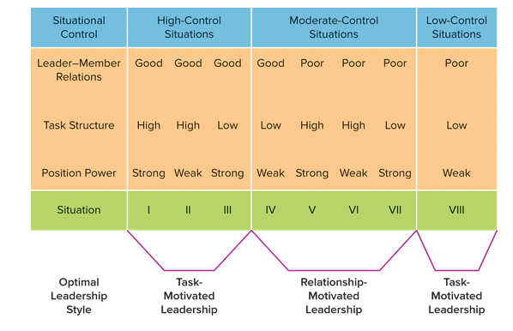

Take-Aways from Fiedler’s Model

Although research provides only partial support for Fiedler’s model and the LPC scale, there are three key take-aways.

Leadership effectiveness goes beyond traits and behaviors. The fit between a leader’s style and the situational demands is influential. For example, a recent study found that companies with task-oriented CEOs achieved greater financial performance (higher return on assets) when the company had a relationship-focused culture, whereas firms with relationship-oriented CEOs had higher firm performance in task-focused cultures.

Organizations should attempt to hire or promote people whose leadership styles fit or match situational demands. Bill Marriott, Marriott’s executive chairman, decided to select the first nonfamily CEO because he felt his son John was not suited for the position despite having spent his entire life working his way up through the company (see Problem-Solving Application box).

Leaders need to modify their style to fit a situation. A recent study found that too much task-oriented leader behavior was viewed negatively by employees, whereas excessive relationship leadership was not. Leaders need to experiment with finding the appropriate amount of leadership to exhibit in different situations.

A second popular contingency-based theory, proposed by Robert House in the 1970s and revised in 1996, is path-goal theory, which holds that leader behaviors are effective when employees view them as a source of satisfaction or as paving the way to future satisfaction. Leaders are expected to do this by (1) reducing roadblocks that interfere with goal accomplishment, (2) providing the guidance and support employees need, and (3) linking meaningful rewards to goal accomplishment.

House’s revised model is presented in Figure 13.4. You can see that leadership effectiveness is influenced by the interaction between eight leadership behaviors (see Table 13.4) and a variety of contingency factors.

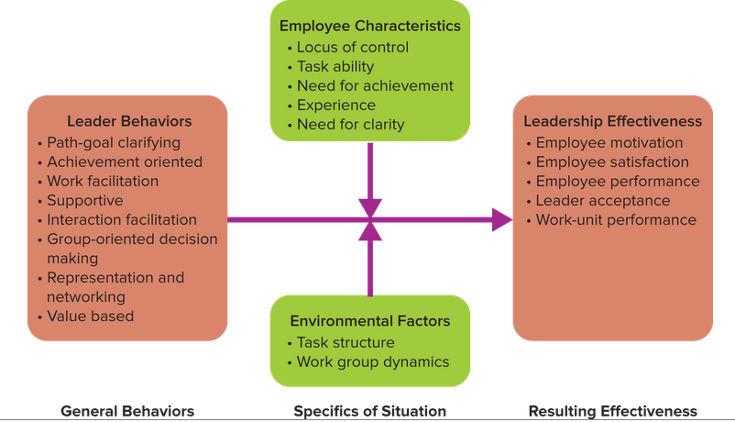

What Determines Leadership Effectiveness? The Match between Leadership Behavior and Contingency Factors,

Figure 13.4 shows that two contingency factors, employee characteristics and environmental factors, can cause some leadership behaviors to be more effective than others.

Does the Revised Path-Goal Theory Work?

There are not enough direct tests of House’s revised path-goal theory to draw overall conclusions. Nonetheless, the theory offers us three key points.

(1) Use more than one style of leadership. Effective leaders use multiple types of leader behavior. Familiarize yourself with the eight types of leader behavior outlined in path-goal theory and try new behaviors when the situation calls for them.

(2) Help employees achieve their goals. Clarify the paths to goal accomplishment and remove any obstacles that may impair an employee’s ability to achieve his or her goals.

(3) Modify your leadership style to fit various employee and environmental characteristics. Remember that a small set of employee characteristics (ability, experience, and need for independence) and environmental factors (task characteristics of autonomy, variety, and significance) are relevant contingency factors.

Applying Contingency Theories,

Step 1: Identify important outcomes. Managers must first identify the goals they want to achieve. For example, the head coach may have games to win or wish to avoid injury to key players, whereas a sales manager’s goal might be to increase sales by 10 percent or reduce customers’ complaints by half.

Step 2: Identify relevant leadership behaviors. Next managers need to identify the specific types of behaviors that may be appropriate for the situation at hand. The list in Table 13.4 is a good starting point. A head coach in a championship game, for instance, might focus on achievement-oriented and work-facilitation behaviors. In contrast, a sales manager might find path-goal , clarifying, work-facilitation, and supportive behaviors more relevant for the sales team. Don’t try to use all available leadership behaviors. Rather, select the one or two that appear most helpful.

Step 3: Identify situational conditions. Fiedler and House both identify a set of potential contingency factors to consider, but there may be other practical considerations. For example, a star quarterback on a football team may be injured, which might require the team to adopt a different strategy for winning the game. Similarly, the need to manage a virtual sales team with members from around the world will affect the types of leadership most effective in this context.

Step 4: Match leadership to the conditions at hand. There are too many possible situational conditions for us to provide specific advice. This means you should use your knowledge about organizational behavior to find the best match between your leadership styles and behaviors and the situation at hand. The coach whose star quarterback is injured might use supportive and values-based behaviors to instill confidence that the team can win with a different quarterback. Our sales manager also might find it useful to use the empowering leadership associated with work-facilitation behaviors and avoid directive leadership.

Step 5: Decide how to make the match. Managers can use guidelines from either contingency theory or path-goal theory: change the person in the leadership role or change his or her behavior. It is not possible to change the head coach in a championship game. This means the head coach needs to change his or her style or behavior to meet the specific challenge. In contrast, the organization employing the sales manager might move him or her to another position because the individual is too directive and does not like to empower others. Or the sales manager could change his or her behavior, if possible.

## 13.5 Transformational Leadership: How do Leaders Transform Employees’ Motives?

Transformational leadership represents a broad type of leader behavior that goes beyond task and relational leadership. Its origins date to the 1940s, when German sociologist Max Weber discussed the pros and cons of charismatic leadership. Charisma is a form of interpersonal attraction that inspires acceptance, devotion, and enthusiasm. Weber’s initial ideas were examined and then incorporated into different models of transformational leadership during the 1970s and ’80s. The dominant model of transformational leadership was proposed by a renowned OB scholar, Bernard Bass. Bass believed transformational leaders used key leader behaviors to influence others.

A Model of Transformational Leadership,

Transformational leaders transform their followers to pursue organizational goals over self-interests. They do this by appealing to followers’ self-concepts , their values, motives, and personal identity. There are four key behaviors of transformational leaders: inspirational motivation, idealized influence, individualized consideration, and intellectual stimulation. Figure 13.5 provides a sketch of the way transformational leaders rely on the four behaviors. Let’s look at each in more detail.

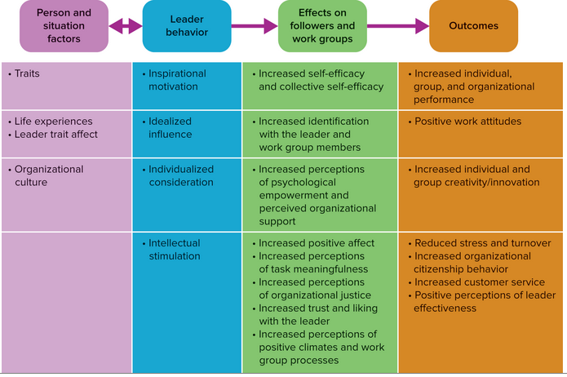

Inspirational Motivation

Let me share a vision that elevates us to a greater good. Inspirational motivation, which includes the use of charisma, relies on an attractive vision of the future, emotional arguments, and demonstrated optimism and enthusiasm. A vision is a realistic, credible, attractive future for your organization. According to Burt Nanus, a leadership expert, the right vision unleashes human potential because it serves as a beacon of hope and common purpose. It does this by attracting commitment, energizing workers, creating meaning in employees’ lives, establishing a standard of excellence, promoting high ideals, and bridging the gap between an organization’s present problems and its future goals and aspirations.

Idealized Influence,

Let me demonstrate how to work hard and do the right thing. The focus of idealized influence is to instill pride, respect, and trust within employees. Managers do this by sacrificing for the good of the group, being a role model, and displaying high ethical standards.

Individualized Consideration,

Let me provide tangible support to help you reach your goals. The individualized consideration part of transformational leadership is about relationships. Specifically, individualized consideration consists of behaviors that provide support, encouragement, empowerment, and coaching to employees. To enact these behaviors, leaders must pay special attention to the needs of their followers and search for ways to help them develop and grow. Spend time talking with people about their interests and identify new learning opportunities for them.

Intellectual Stimulation,

Let’s establish challenging and meaningful goals. The intellectual component of transformational leadership is more task-oriented. Intellectual stimulation behavior encourages employees to question the status quo and to seek innovative and creative solutions to organizational problems. If effectively challenged, employees are more likely to view organizational problems as my problems and proactively attempt to overcome performance roadblocks.

How Does Transformational Leadership Work?

Figure 13.5 showed on the left-hand side that transformational leader behavior is first influenced by both person and situation factors. On the person factor side of the equation, research reveals that transformational leaders tend to have personalities that are more extroverted, agreeable, and proactive and less neurotic than non-transformational leaders. They also have higher emotional intelligence88 and tend to be female. Leader trait affect, which represents a person's tendency to feel either positive or negative, also influences how well we use transformational leadership, because positive people are more likely to engage in transformational leadership than negatively oriented individuals.

Implications for Managers,

The establishment of a positive vision of the future, inspirational motivation , should be considered a first step in applying transformational leadership. Why? Because the vision represents a long-term goal, and it is important for leaders to begin their influence attempts by gaining agreement and consensus about where the team or organization is headed. It also is critical to widely communicate the vision among the team or entire organization. People can’t get excited about something they don’t know about or don’t understand.

The best leaders are not just transformational. Effective leaders also rely on other task-oriented and relationship-oriented behaviors, and they avoid a laissez-faire or wait-and-see style. Use all types of leader behavior discussed in this chapter, when appropriate.

Transformational leadership affects outcomes at the individual, group, and organizational levels. Managers can use the four types of transformational leadership shown in Figure 13.5 (second column from left) as a vehicle to improve a host of important outcomes.

Transformational leadership works virtually. If you lead geographically dispersed people, focus on how you can display the four transformational leader behaviors in your e-mails, tweets, webinars, and conference calls.

Transformational leaders can be ethical or unethical. While ethical transformational leaders enable employees to enhance their self-concepts, unethical ones select or produce obedient, dependent, and compliant followers.

## 13.6 Additional Perspectives on Leadership,

The Leader, Member Exchange (LMX) Model of Leadership

Leader, member exchange (LMX) theory is based on the assumption that leaders develop unique one-to-one relationships (exchanges) with each of the people reporting to them. Behavioral scientists call this sort of relationship a vertical dyad (a dyad is something with two parts). The forming of vertical dyads is said to be a naturally occurring process, resulting from the leader’s attempt to delegate and assign work roles. Two distinct types of LMX relationships are expected to evolve, in-groups and out-groups.

In-Group vs. Out-Group Exchanges,

* In-group exchange: Creating trust and mutual obligation. High in-group exchanges, also called high LMX, are characterized by a partnership of reciprocal influence, mutual trust, respect and liking, and a sense of common fate. These relationships become more social over time.
* Out-group exchange: Creating more formality in expectations and rewards. Out-group exchanges, also known as low LMX relationships, tend to focus on the economic exchange between leaders and followers. They tend to be more formal and revolve around negotiating the relationship between performance and pay. They do not create a sense of mutual trust, respect, or common fate.

Does the Quality of an LMX Matter?

How Are LMX Relationships Formed?

The quality of an LMX is influenced by three categories of variables: follower characteristics, leader characteristics, and interpersonal relationship variables.

Follower characteristics. Leaders tend to create higher LMXs with employees they perceive as possessing competence, positive personalities, agreeableness, conscientiousness, and extraversion. Do you possess these characteristics?

Leader characteristics. Leaders who use transactional and transformational leadership tend to have higher LMXs. Not surprisingly, so do extroverted and agreeable leaders.

Interpersonal relationship variables. Far too many interpersonal factors affect an LMX for us to discuss here, so we note three that have the greatest impact on a leader, member relationship. High LMXs tend to occur when the parties:

Managerial and Personal Implications of LMX Theory,

Here are three important managerial and personal implications of LMX theory.

Expectations matter. Leaders are encouraged to establish high-performance expectations for all their direct reports, because favoritism and differential treatment lead to negative outcomes. Leaders should also communicate their view of relationships with their team.

Diversity still counts. Personality and demographic similarity between leaders and followers may be associated with higher LMXs, but managers should avoid creating a homogenous work environment just for the sake of having positive relationships with their direct reports. Diversity’s many benefits are too powerful to be ignored.

The initiative is yours. Positive actions can improve a poor LMX (see the Applying OB box). Take the lead rather than waiting for your boss to change the relationship. Self-Assessment 13.5 will help you diagnose the quality of your relationship with a boss and discover how you can improve it.

What Do Leaders Want from Followers?

Followers vary in terms of the extent to which they commit to, comply with, or resist a leader’s influence attempts. For example, one researcher identified three types of followers: helpers, independents, and rebels.

* Helpers show deference to and comply with the leadership.
* Independents distance themselves from the leadership and show less compliance.
* Rebels show divergence from the leader and are least compliant.

Leaders obviously want followers who are:

1. Productive
2. Reliable
3. Honest
4. Cooperative
5. Proactive
6. Flexible

What Do Followers Want from Leaders?

Followers seek, admire, and respect leaders who foster three emotional responses in others:

(1) Significance

(2) Community

(3) Excitement

How Can I Become a Better Follower?

A pair of OB experts developed a four-step process for followers to use in managing the leader, follower relationship.

1. Understand your boss. Gain an appreciation for your manager’s leadership style, interpersonal style, goals, expectations, pressures, and strengths and weaknesses. One way is to ask him or her these seven questions:
   1. How would you describe your leadership style? Does it change when you are under pressure?
   2. When would you like me to approach you with questions or information? Are any situations off-limits (like social events)?
   3. How do you want me to communicate with you?
   4. Do you have any preferred or unique ways of working?
   5. Are there behaviors or attitudes you won’t tolerate? What are they?
   6. What is your approach to giving feedback?
   7. How can I help you?
2. Understand your own style, needs, goals, expectations, and strengths and weaknesses.
3. Conduct a gap analysis between the understanding you have about your boss and the understanding you have about yourself.
4. Build on mutual strengths and adjust or accommodate your boss’s divergent style, goals, expectations, and weaknesses. For example, you might adjust your style of communication in response to your boss’s preferred method for receiving information. Or if the boss prefers participative decision making, consult him or her in all decisions regardless of your own style. Most managers are pushed for time, energy, and resources and are more likely to appreciate followers who save rather than cost them these. Avoid using your manager’s time discussing trivial matters.

## What Did I Learn?

You learned that being an effective leader requires appropriate leadership behavior that you can learn and develop. The integrated model of leadership allows you to understand the many factors contributing to leadership effectiveness. You also learned the importance of being a good follower. Reinforce your learning with the Key Points below. Consolidate your knowledge by using the Organizing Framework. Then challenge your mastery of the material by answering the Major Questions in your own words.

Key Points for Understanding Chapter 13,

You learned the following key points.

13.1 Making Sense of Leadership Theories,

You do not need to have a formal position of authority to lead.

Figure 13.2 shows an integrated model of leadership. The extent to which people effectively use the four key leader behaviors, task-oriented, relationship-oriented, passive, and transformational, is a function of demographic characteristics, intelligence and skills, task-oriented traits, and interpersonal attributes.

Effective leadership requires effective managerial skills at some level.

13.2 Trait Theories: Do Leaders Possess Unique Traits and Personal Characteristics?

Table 13.1 summarizes the positive task-oriented traits and positive/negative interpersonal attributes leaders possess.

Emotional intelligence contributes to transformational leadership and is positively associated with leader effectiveness.

There are both similarities and differences in the leadership traits possessed by men and by women.

Leaders need four key skills: cognitive abilities, interpersonal skills, business skills, and strategic skills.

People hold mental prototypes of effective and ineffective leaders.

13.3 Behavioral Theories: Which Leader Behaviors Drive Effectiveness?

Four categories of leader behavior are task-oriented, relationship-oriented, passive, and transformational.

Task-oriented leadership includes the use of initiating structure and transactional leadership.

Relationship-oriented leadership includes the use of consideration, empowerment, servant leadership, and ethical leadership.

Followers experience psychological empowerment when leaders create perceptions of meaningfulness, self-determination or choice, competence, and impact.

Servant-leadership focuses on increased service to others rather than ourselves. Servant-leaders display the characteristics in Table 13.3.

Ethical leadership focuses on doing the right thing and establishing norms of ethical behavior.

Passive leadership, also known as laissez-faire leadership, is demoralizing and makes employees feel unsupported. Avoid it!

13.4 Contingency Theories: Does The Effectiveness Of Leadership Depend On The Situation?

Contingency theories are based on the idea that the effectiveness of leadership depends on the situation at hand.

Fiedler believes leadership effectiveness depends on an appropriate match between leadership style and situational control. Leaders are either task- or relationship-oriented, and the situation is composed of leader, member relationships, task structure, and position power.

House’s path-goal theory holds that leader behaviors are effective when employees view them as a source of satisfaction or as paving the way to future satisfaction. In this respect, leaders exhibit eight styles or categories of leader behavior. In turn, the effectiveness of these styles depends on various employee characteristics and environmental factors.

Researchers suggest a five-step approach for applying contingency theories.

13.5 Transformational Leadership: How do Leaders Transform Employees’ Motives?

Transformational leaders motivate employees to pursue organizational goals above their own self-interests.

Transformational leaders rely on four unique types of leader behavior: inspirational motivation, idealized influence, individualized consideration, and intellectual stimulation.

Person and situation factors influence the extent to which people use transformational leadership.

The use of transformational leadership has positive effects on followers and work groups. In turn, these positive effects foster positive individual, group, and organizational performance.

13.6 Additional Perspectives on Leadership,

The LMX model revolves around the development of dyadic relationships between managers and their direct reports. These leader, member exchanges result in either in-group or out-group relationships.

Humility is a stable trait associated with the belief that something is more important than the self. Humble leaders exhibit five key qualities: high self-awareness, openness to feedback, appreciation of others, low self-focus, and appreciation of the greater good.

It is hard for leaders to be effective if they have poor followers. Leaders want followers who are productive, reliable, honest, cooperative, proactive, and flexible. People are more likely to be positive followers when the leader creates feelings of significance, community, and excitement.

To improve the relationship with a boss, followers should first understand the boss. Second, followers should understand their own style, needs, goals, expectations, and strengths and weaknesses. Third, they should conduct a gap analysis between the understandings they have about their boss and about themselves. Finally, followers can build on mutual strengths and adjust to or accommodate the leader’s different style, goals, expectations, and weaknesses.

The Organizing Framework for Chapter 13

As shown in Figure 13.6, you learned a host of person and situation factors that influence the leadership processes identified in the figure. You also understand the breadth and power of leadership by looking at the Outcomes box of the framework. Here you see the individual-, group/team-, and organizational-level outcomes affected by leadership.